

IISS1003 Integrating Indigenous Science and STEM

**Assessment Guide**

**Trimester 2, 2022**

Colleges of Business and Technology WA Pty Ltd T/A Curtin College CRICOS Provider Code 02042G

## **UNIT OUTLINE AND ASSESSMENT GUIDE**

The Unit Outline and the Assessment Guide for IISS1003 Integrating Indigenous Science and STEM provide the full requirements of the unit and both should be referred to when completing unit assessments.

Please make sure that you keep saved versions of your work that show your progress in case of needing to demonstrate academic integrity.

## **PRESENTATION OF WRITTEN ASSIGNMENTS**

In all the written assessments for this unit, it is important that you present your work in a way that communicates a **professional attitude.** Below are some formatting rules that should be followed for each written assessment:

* Type or word-process your assessment
* Use a 12- font size
* Use Arial font
* Leave a margin of 2.5 cm around all four sides of the page
* Use double spacing between lines
* Use a Header to insert your name and student ID number at the top of the page
* Number pages clearly
* Keep a copy of your submitted assessments

See also the APA style cover page for each assessment: <https://apastyle.apa.org/style-grammar-guidelines/paper-format/title-page>

For Reference List:

* Formatted according to the APA 7th Edition referencing style;
* Use single space for each source entry; and
* Use double space between entries.

## **Assessments/Exams**

For Mode 2 (online mode Live via zoom) students, the unit assessments/exams will require you to complete them on a device (laptop or desktop computer) that has both a working webcam and microphone function with stable internet connection. Assessment submissions are via Turnitin. You may also be invigilated through zoom.

For Mode 1 (face to face in class) students, assessments/exams will require you to complete them on a device (laptop or computer) before submission on Turnitin. Oral assessments (presentations) will be conducted in class.

## **Supplementary Assessment / Exam**

A supplementary assessment may be granted to a student by the Board of Examiners in order to provide an additional opportunity for a student to pass a unit. If a student passes a supplementary assessment their total mark will not change but their grade becomes a pass grade (PX – Pass with Supplementary). Students who have qualified for a supplementary assessment will be notified by e-mail following the Board of Examiners. Supplementary assessments will be generally conducted in the Orientation week of the next study period unless otherwise advised by the College and students must be available to sit the assessment at the specified time otherwise the offer will be withdrawn. It is the responsibility of students to be available to complete the requirements of a supplementary assessment. A maximum of two supplementary assessments may be granted to the same student in a program. For more information, please refer to the Curtin College’s **Supplementary Assessment Policy** which is located under Policies and Procedures on the College’s website at <http://www.curtincollege.edu.au>.

## **Deferred Final Assessment/Exam (if applicable)**

Within two calendar days following the missed Final Assessment/Exam complete the “Application for Assessment Extension Form” located on Moodle unit: Study Kiosk/*Academic Forms & Documents* and attach valid evidence, for example, a medical certificate/ or a letter from the counsellor, and a statement outlining the reasons for missing the final exam. Submit all documents to Reception in Building 205 or email them to [help@curtincollege.edu.au](mailto:help@curtincollege.edu.au). Deferred Final Assessment/Exams will be generally conducted in the Orientation week of the next study period unless otherwise advised by the College and students must be available to sit the assessment at the specified time.

## For information on the deferred assessment conditions, please refer to the Curtin College’s Assessment and Moderation Policy which is located under Policies and Procedures on the College’s website: <http://www.curtincollege.edu.au> .

## **WEEKLY LEARNING SCHEDULE**

Each week you should refer to the Weekly Learning Schedule in the Unit Outline to see what topics will be covered in class that week, how they connect to the Learning Outcomes for the unit and which assessments are due.

### **Tuition Pattern**

* **Lecture recordings** – Asynchronous sessions i.e. pre-recorded weekly lectures on the Moodle unit page, which provides detailed explanation of the learning content. Students are expected to watch the pre-recorded weekly lectures to actively engage with the unit, learn critical content for their assessments and prepare for the tutorials.
* **Pre-tutorial preparation materials** –These materials are in preparation for the assessments and for class activities. Students are expected to complete these materials before class to learn critical content for their assessments, actively engage with the unit and prepare for the tutorials.
* **Tutorials** - Weekly (usually three hours) live zoom sessions outline key concepts and learning focus areas. This focuses on the application of the unit content through collaborative peer learning, in class individual/group activities and progressive work that scaffolds towards assessment milestones. It is your responsibility as the student to watch the lecture recordings prior to the tutorials, so that you can proactively participate in the learning activities.

**DETAILED INFORMATION ON ASSESSMENT TASKS**



**Assessment 1 Portfolio**

Due Date: Weekly Fridays 11.50pm (see Unit Outline)

Weighting: 50%

**Assessment Task**

You will be required to submit a piece of work aligned with either the topic for that week or the assessment tasks. These are generally not difficult or lengthy tasks, but they ensure that you are working towards the completion of the larger tasks for the semester. Each task requires a reasonable submission to gain marks.

* Week 1 – PELA Diagnostic Task
* Week 2 – Evidence-based Writing Task (10%)
* Week 3 – Research Task (Preparation for Argument Plan)
* Week 4 – Thesis Statement (Preparation for Argument Plan)
* Week 5 – Argument Plan (10%)
* Week 12 – Scientific Argument Essay (30%)

**Assessment Task (Scientific Argument Essay 30%)**

This assessment task is designed to start you on the track of mastering the art of evidence-based scientific writing. It takes to time develop and is something that we continue to work on throughout our professional careers. Your portfolio tasks are scaffolded so that the final output for this assessment is as high quality as possible. Please use this experience and your feedback from it to develop your writing skills in future units.

Research and write an argumentative essay that demonstrates engagement between Western science and Indigenous knowledge systems. Topics need to be discussed with your tutor/workshop facilitator.

* Construct a piece of evidence-based academic writing (a scientific argument) that fully supports a thesis
* Word limit: 1000-1500 words (excluding references)
* Minimum of 10 academic references
* Use appropriate paraphrasing and relevant evidence to support or refute your argument that is correctly referenced (in-text and end-of-text). Direct quotes are not encouraged.
* Self-evaluate your work using the marking rubric provided.
* Please note APA7th referencing style replaces all mention of APA6th style below.

**Submission Requirements**

Please refer to the weekly submission points on Moodle and the Weekly Learning Schedule in the Unit Outline.

**Marking Criteria & Feedback**

Please refer to the rubrics provided.

Evidence-based Writing Task Marking Criteria and Feedback

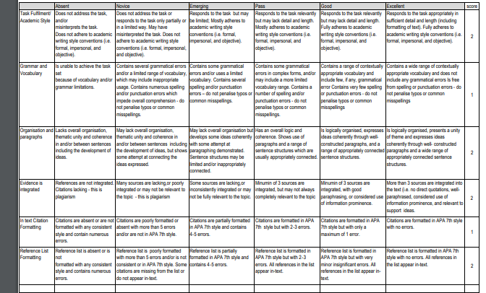



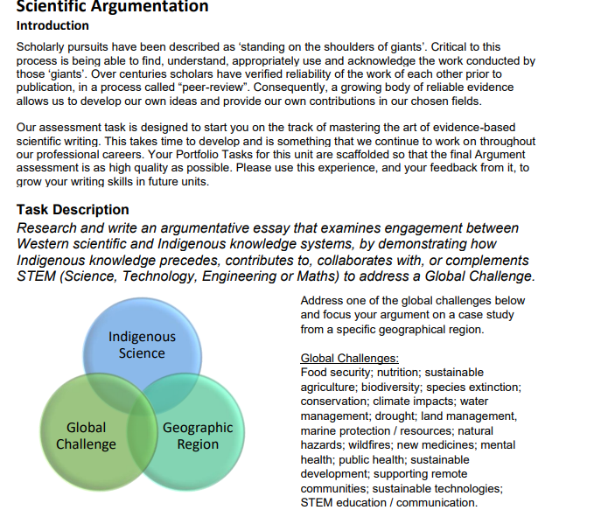



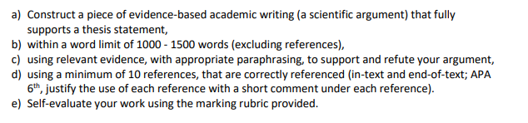



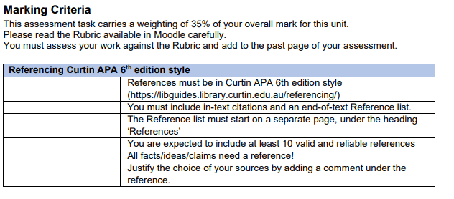



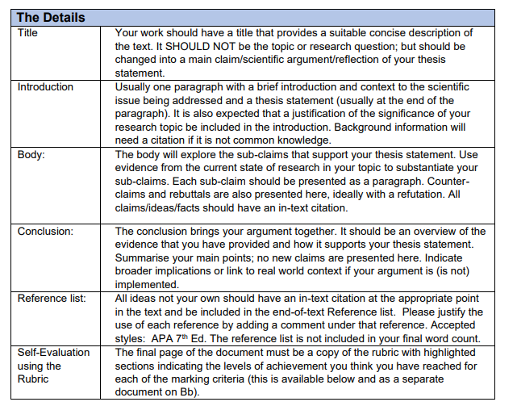



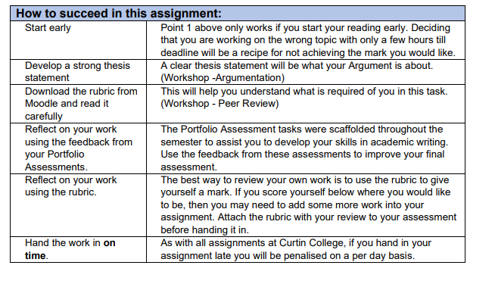

Argumentative Essay Rubric

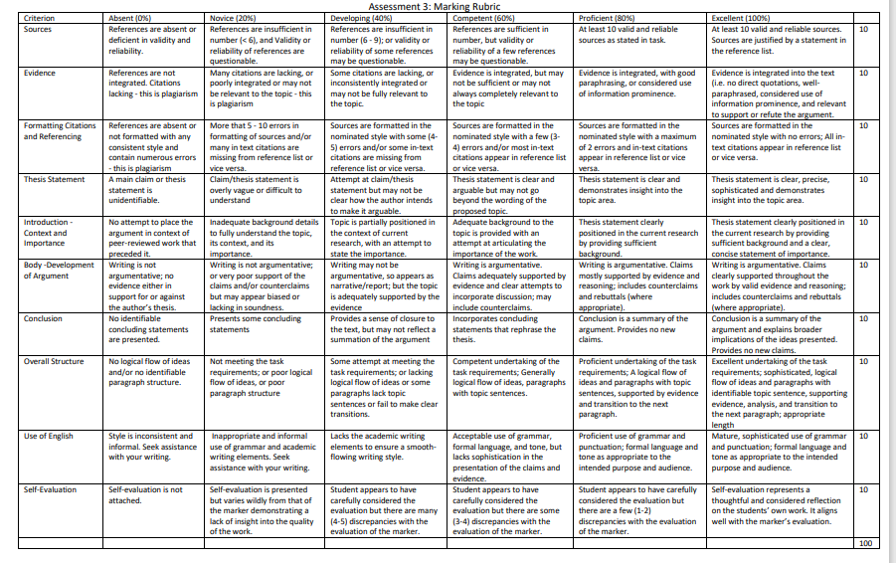



**Assessment 2 Academic Reflection**

Due Date: Fridays 11.50pm Week 12

Weighting: 20%

**Assessment Task**

The Academic Reflection requires students to reflect on a specific part of the Unit topic, by writing an academic reflection using the 4R Model (report, relate, reason, reconstruct). Part of the reflection will be evidence-based and at least 3 references are required.

* Word limit: 300-500 words (excluding references)
* Minimum of 3 academic references
* Correctly referenced (in-text and end-of-text). Direct quotes are not encouraged.

**Submission Requirements**

Please refer to the weekly submission points on Moodle and the Weekly Learning Schedule in the Unit Outline.

**Marking Criteria & Feedback**

Please refer to the rubrics provided.

Academic Reflection Rubric



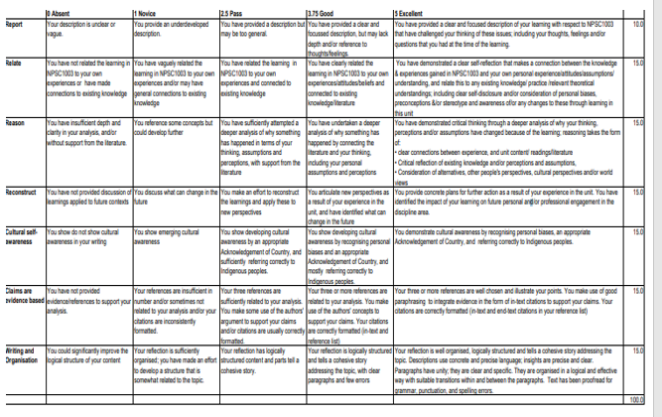

**Assessment 3: Presentations and Group Work**



Assessed Weekly in Class from Weeks 3-12

Weighting: 30%

**Assessment Task**



For this assessment, students are required to actively participate in class discussions, group activities requiring research, group work, reporting back to class on research results and mini-presentations.

Students can receive a maximum mark of 3/3 (3%) during class (for 10 class sessions) depending on their level of participation and demonstration of outcomes from group work and research during each session.

**Introduction**

Oral presentation skills, group work and research are important because the product of your STEM work needs to be evidence-based and shared with a wider audience. Clear reporting IS the delivery of your product, and the value of your work will be judged by how well you can explain your findings to an audience with research support.

Furthermore, most projects (from pure science to industry projects) are team exercises. They draw on the strengths and expertise of team members to build an output that responds to a problem and/or generates new knowledge. Teams typically produce more frequently cited research than individuals (Wuchty, Jones & Uzzi, 2007). Therefore, engaging in mini-group presentations for this Unit can help to build team collaboration and communication skills for your future projects.

The purpose of this assessment task is to practice the scientific behaviours of communicating your science to others in a small team after group collaboration and research. Presenting takes quite a bit of preparation: crafting the story, preparing the visual elements (in this case PowerPoint) and practicing the oral delivery.

Apart from being marked for class and group participation in group work and discussions, students will also be marked on elements of the presentation rubric below.

Marking Criteria-Please see Rubric



* Content, research and findings – research is directed, sources relevant, clear articulation of findings, cultural content explained, addresses the task, includes Acknowledgement;
* PowerPoint – effective and engaging, attractively designed and crafted; legible graphs, tables, pictures, objects;
* Referenced appropriately – Sources of information relevant, appropriately referenced and formatted (in-text slides and end of text);
* Oral presentation/verbal skills – Delivery techniques and appropriate language suitable for a STEM audience make the presentation compelling. Speakers speak clearly and use appropriate tone, volume and pace. Expands on details on the slides, not reading.
* Group cohesion – consistent presentation; clear flow; all parts connected.

